# LESSON 2. FIRST TEST PROGRAM

## 2.1. PROGRAM STRUCTURE

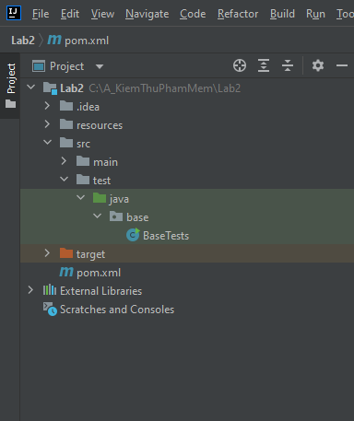

Figure 2. . Structure

## 2.2. PROGRAM CODE

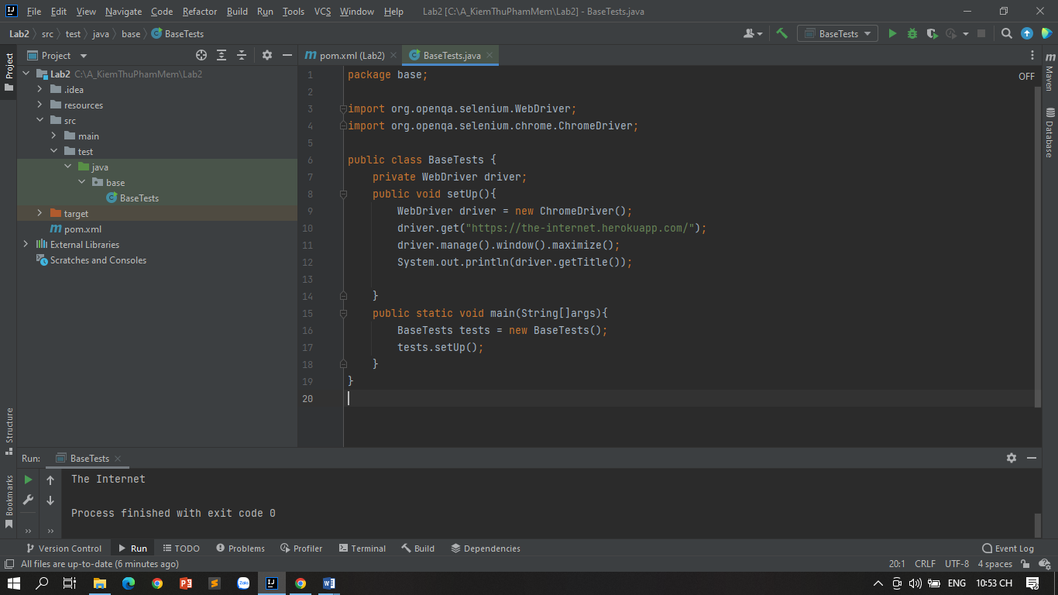

Figure 2. . File BaseTests.java

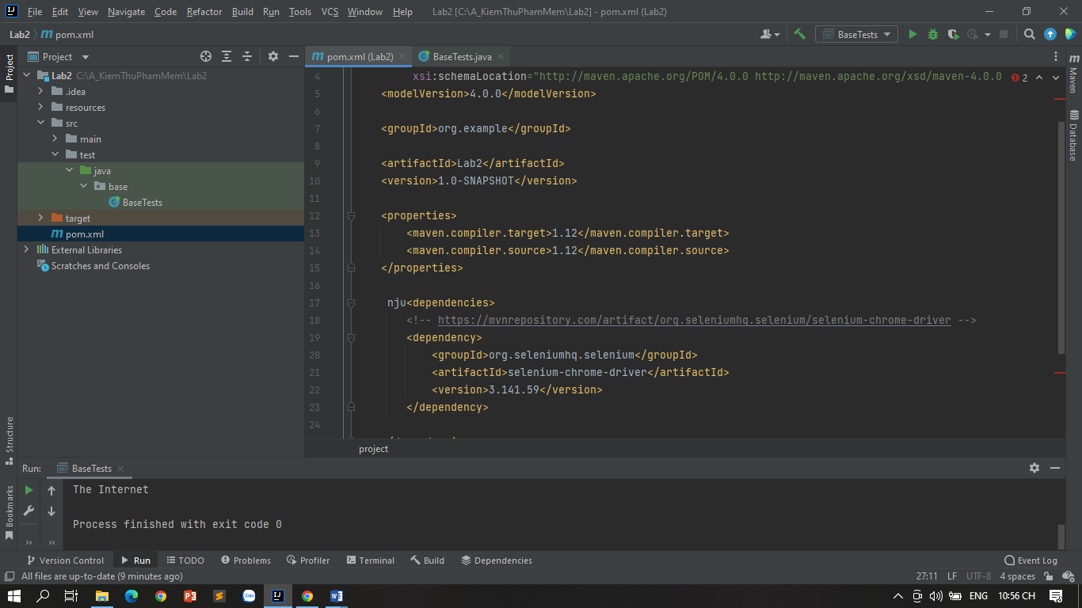

Figure 2. . File pom.xml

## 2.3. RESULTS

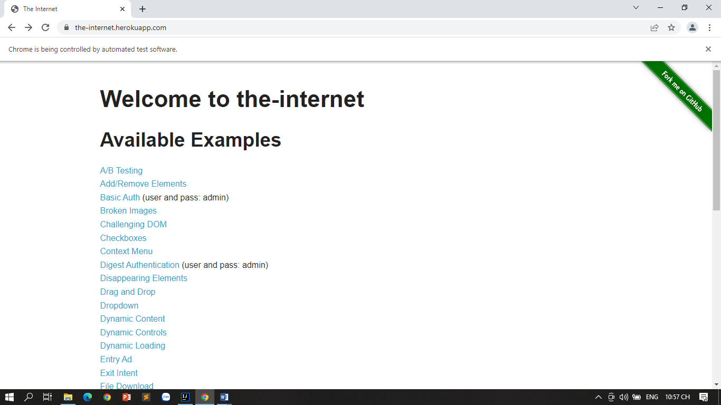

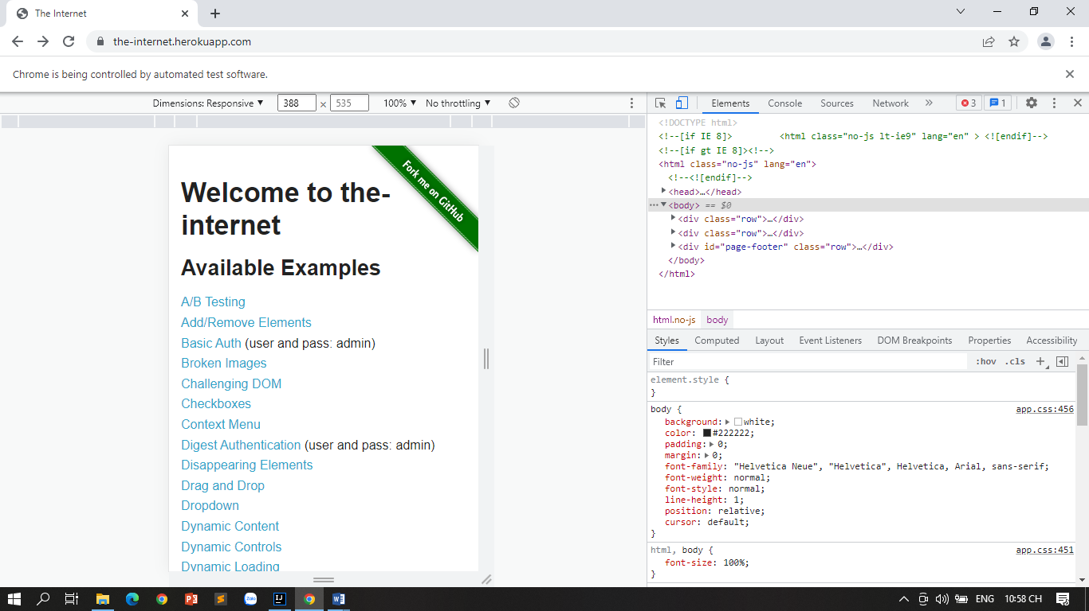

Đổi link: https://newshop.vn/

